1. Person class

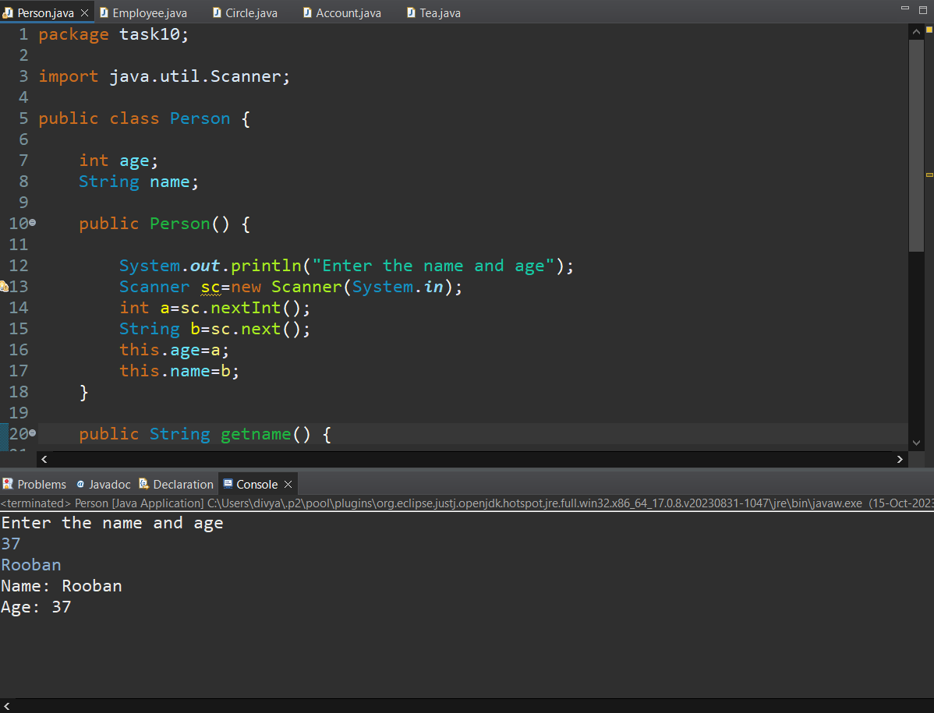

1. Employee class



1. Circle class



1. Account class



1. Tea class



1. Tea override class

